MARBLE RUN CHALLENGE
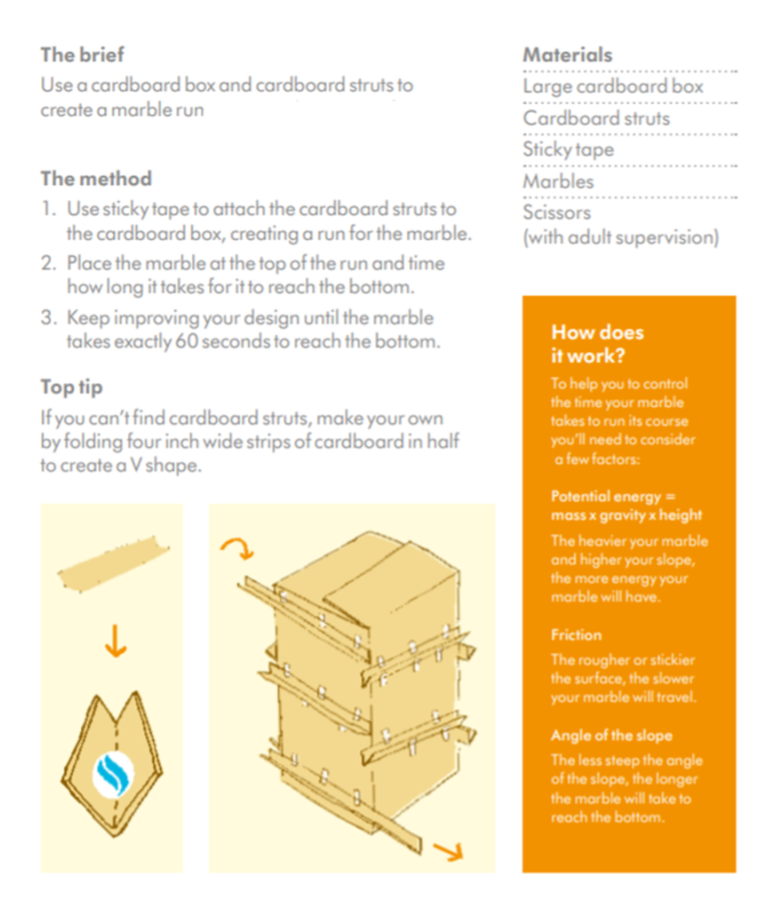
Use this for some ideas to help or get creative and design your own solutions to solve the problem.

