THESE ARE THE HANDS (COVID 19)
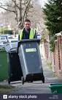
These are the hands that emptied rubbish
These are the hands that take waste
These are the hands that collect cardboard
These are the hands that drive lorry’s

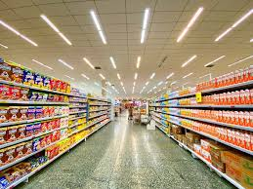
These are the hands that stayed open
These are the hands that made deliveries
These are the hands that sold food
These are the hands that stock shelves
These are the hands that kept clean
These are the hands that kept fit
These are the hands that be silly
These are the hands that help children
These are the hands that dress up
These are the hands that have fun with family

These are the hands that open schools
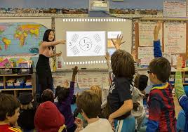
These are the hands that look after kids
These are the hands that kept safe
These are the hands that can be fun
These are the hands that set work

Those are the hands that helped us in this time

