# 

# Cookridge Holy Trinity

# Church of England (A) Primary School

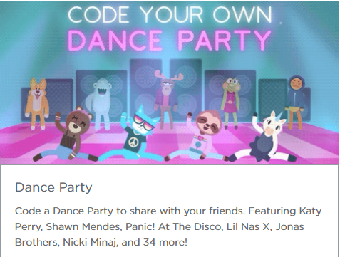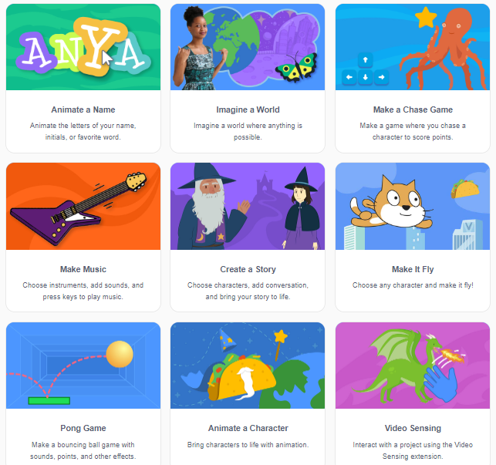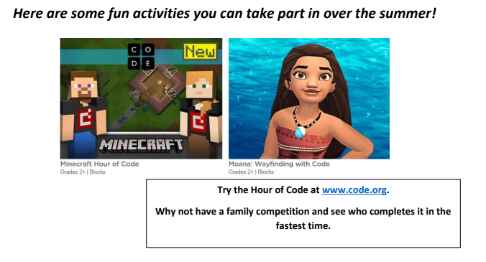**Computing Summer Challenge 2020**

**Use your coding knowledge to create a dance party to some of your favourite songs:** [**https://studio.code.org/s/dance-2019/stage/1/puzzle/1**](https://studio.code.org/s/dance-2019/stage/1/puzzle/1)

**Try some of the challenges on Scratch:** <https://scratch.mit.edu/ideas>

**Try the hour of code at:** <https://code.org/hourofcode/overview>