Wednesday 18th March 2020
LO: To compare the daily lives of children today and in Ancient Roman time
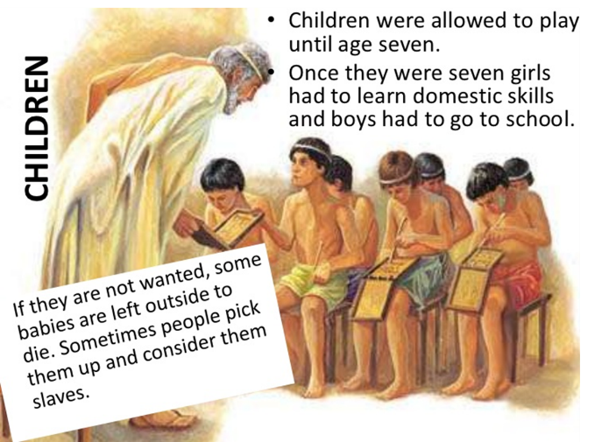
R- What happened to unwanted babies?
I- Who is the man in the picture? How do you know?
C- Why did the Romans choose not to let girls go to school?

Wednesday 18th March 2020
LO: To compare the daily lives of children today and in Ancient Roman time
R- What happened to unwanted babies?
I- Who is the man in the picture? How do you know?
C- Why did the Romans choose not to let girls go to school?

Wednesday 18th March 2020
LO: To compare the daily lives of children today and in Ancient Roman time
R- What happened to unwanted babies?
I- Who is the man in the picture? How do you know?
C- Why did the Romans choose not to let girls go to school?

